Test 1: Sample Test

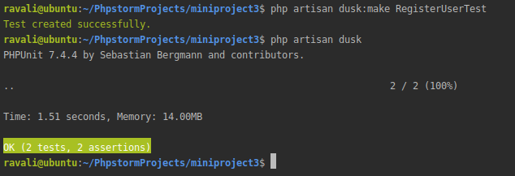

Test 2: Login User Test

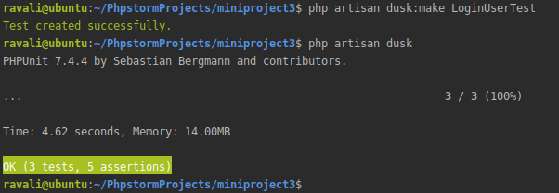

Test 3: Create Question Test

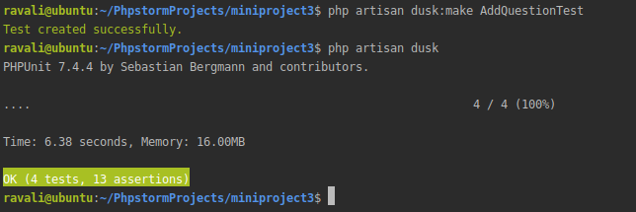

Test 4: Add Answer Test

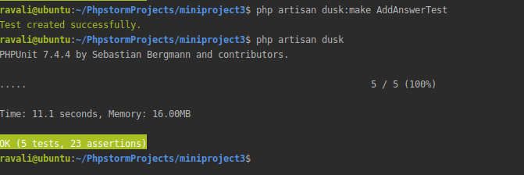

Test 5: Register User Test

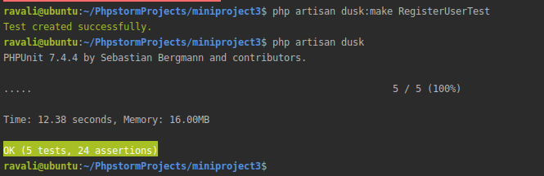

Test 6: View Question Test

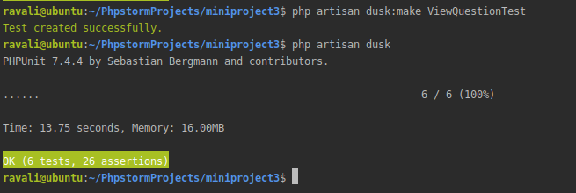

Test 7: Edit Question Test

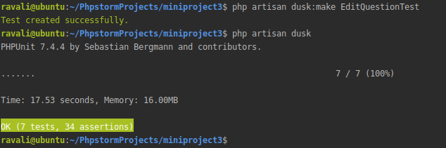

Test 8: Delete Question Test

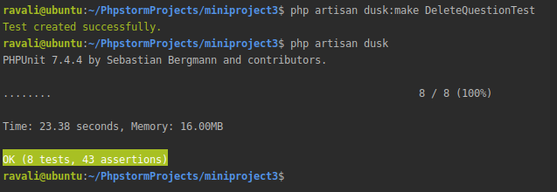

Test 9: View Answer Test

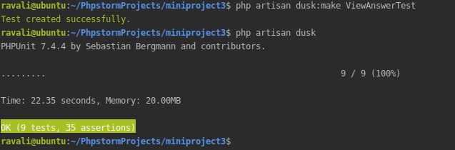

Test 10: Edit Answer Test

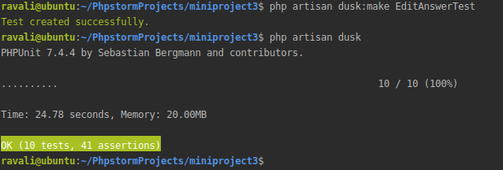

Test 11: Delete Answer Test

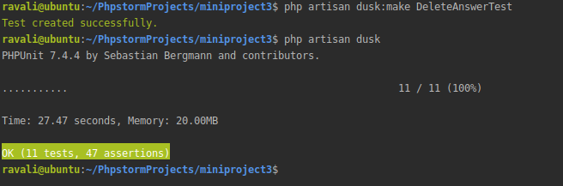

Test 12: Check Profile Test

